How to Reduce the Spread of COVID-19

COVID-19 has killed over 4 million people worldwide and 640,000 people in the US. The coronavirus that causes COVID-19 has been evolving to become more contagious; this has resulted in more cases of COVID-19 and more deaths. To prevent more deaths and the evolution of more dangerous versions of the coronavirus, we need to reduce the total number of COVID-19 cases.

To understand how we can reduce the spread of the coronavirus, watch the video “How Coronavirus Spreads Outdoors vs. Indoors” (https://www.youtube.com/watch?v=n6QwnzbRUyA).

1. Based on this video, list and explain some ways that you can reduce your risk of COVID-19.

How can you reduce your risk of COVID-19? | Explain why this would reduce your risk of COVID-19.

The video was made before COVID-19 vaccines were available, so it does not mention vaccines. Vaccination significantly reduces the risk of coronavirus infection, with especially strong protection against severe COVID-19 that causes hospitalization and sometimes death. Vaccinations are another effective way to reduce the spread of COVID-19. However, vaccines alone can’t do the job of preventing the spread of COVID-19, because:
- The vaccines provide good, but not 100% protection against mild COVID-19.
- Millions of people in the US have an illness or treatment for an illness that has weakened their immune system, so the vaccines are less effective for them.
- Some people are not vaccinated yet; this includes almost all children under 12, since vaccines for them are still being tested.

2. Suppose that you have a classmate who has cancer. His treatment has severely weakened his immune system, so vaccinations are less effective for him. If he gets a coronavirus infection, he is likely to have severe COVID-19. He wants to attend school with his friends. Describe two ways that you and your classmates can reduce his risk of coronavirus infection. Explain your reasoning.

3. The risk of fatal COVID-19 is very low for children and increases with age. Explain how prevention of COVID-19 in children and teens can reduce adult deaths due to COVID-19.

Everyone releases respiratory particles into the air, especially when they talk, shout, sing, sneeze or cough. Larger respiratory particles drop out of the air within a few feet, but tiny respiratory particles can float in the air and spread around a room.  A person who has a coronavirus infection releases respiratory particles that contain coronaviruses. Even if the person does not have any symptoms, their respiratory particles can infect other people.  A mask worn by an infected person reduces the risk that he or she will transmit the infection to others. A mask worn by someone who is not infected reduces the risk that he or she will become infected with the coronavirus. However, some types of masks or ways of wearing a mask are not very effective. | 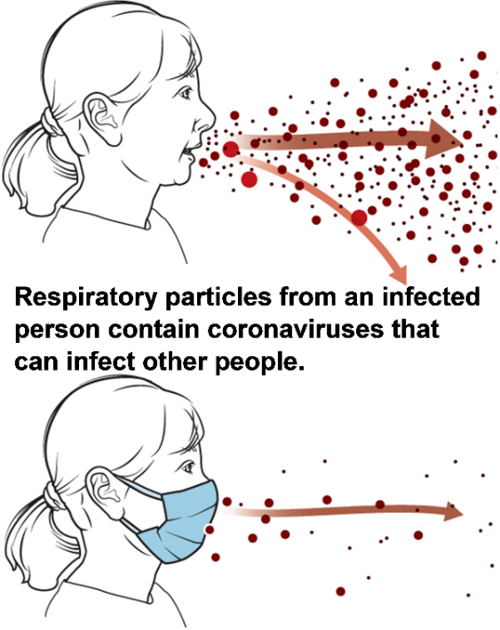

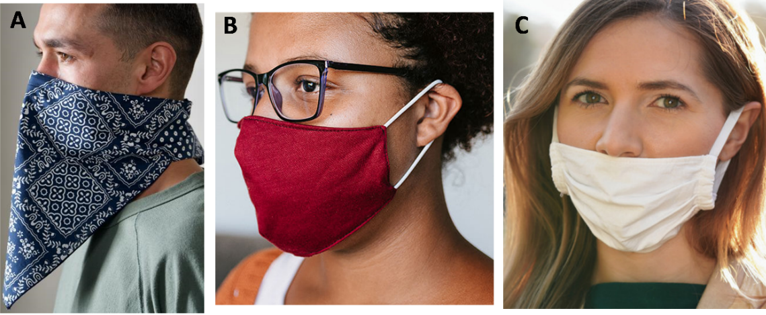
4a. Which picture shows the most effective way to prevent transmission of the coronavirus?
A ___ B ___ C ___

4b. Explain why the face coverings shown in the other two pictures will be less effective.

5. Experts recommend that all students and teachers should be required to wear masks in school. Even those who have been vaccinated and those who don’t have any symptoms of COVID-19 should wear masks when inside a school. Explain the scientific reasons for this recommendation.

By Dr. Ingrid Waldron, Dept Biology, Univ Pennsylvania, © 2021; this Student Handout and Teacher Notes (with instructional suggestions and background biology) are available at https://serendipstudio.org/exchange/bioactivities/coronavirusprev.

